Chapter 10, Solution 12.

Using Fig. 10.61, design a problem to help other students to better understand Nodal analysis.

Although there are many ways to work this problem, this is an example based on the same kind of problem asked in the third edition.

Problem

By nodal analysis, find i_{o} in the circuit in Fig. 10.61.

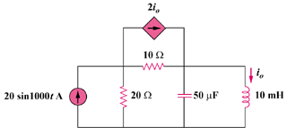

Figure 10.61

Solution

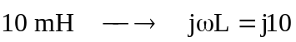
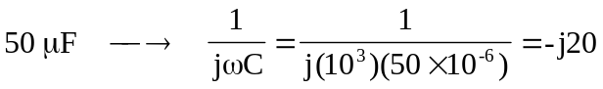

The frequency-domain equivalent circuit is shown below.
2 I_{o}
10 
200 A
V₁

V₂

20 
-j20 
j10 
I_{o}

At node 1,
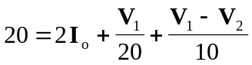, where 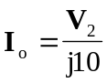
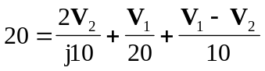
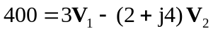 (1)
At node 2,
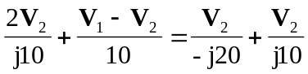
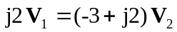
or 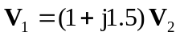 (2)

Substituting (2) into (1),

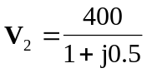

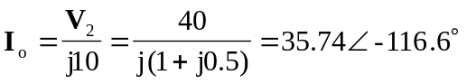

Therefore, 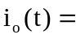 35.74 sin(1000t – 116.6) A

